1. **Description about each part of the house**
2. **Description about each part of the house**

**Living Room**Six 10W LED lamps  
Two 10W wall lamps  
Four 13 A plug sockets   
One 75 W ceiling fan

**Dining and Pantry**Two 5W LED lamps  
Two 10W LED lamps  
One 15W LED lamp  
Four 13 A plug sockets  
One 75 W ceiling fan  
One 2kW Oven  
One 2kW Rice Cooker  
150W Fridge

**Bedroom 1**One 10 W LED lamps   
One 13 A plug sockets  
One 75W Fan

**Bedroom 2**One 10 W LED lamps   
One 13 A plug sockets  
One 75W Fan

**Bedroom 3**Two 10 W LED lamps   
Two 13 A plug sockets  
Two 5W LED lamps  
One 1.2kW A/C

**Toilet**One 10W LED lamp  
One 5W LED lamp  
One 1 kW instantaneous water heater  
Two 13A plug sockets

**Garage**Two 10W LED lamp  
One 15W LED lamp  
Two 13A plug sockets

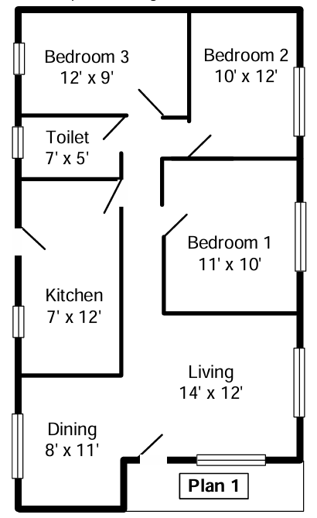

|  |  |  |
| --- | --- | --- |
| **Circuit No** | **Ring / Radial** | **Description** |
| ***Lighting*** | | |
| 1 | Radial | * One 10 W LED lamps in bedroom 1 * One 10 W LED lamps in bedroom 2 * Two 10W and 5W LED lamps in bedroom 3 |
| 2 | Radial | * Two 5W LED lamps in the dining & pantry * Two 10W LED lights in dining & pantry * One 15W LED lamp in the dining & pantry |
| 3 | Radial |  |
| 3 | Radial |  |
| 4 | Radial |  |
| ***Socket Outlets*** | | |
|  | Radial | Four 13 A plug sockets in the dining room |
|  | Radial | Five 13 A plug sockets in the living room |
| 5 | Ring | Six 13 A plug sockets in the kitchen |
| 6 | Radial | Three 13 A plug sockets in bedroom 1 |
| 7 | Radial | Two 13 A plug sockets in bedroom 2 |
| 8 | Radial | Three 13 A plug sockets in bedroom 3 |
| 9 | Radial | A dedicated circuit for the 1.5 kW Air conditioner in bedroom 3 |
| 10 | Radial | A dedicated circuit for the 1 kW instantaneous water heater in the toilet |
| 11 | Radial | A dedicated circuit for the 2.5kW oven unit in the kitchen |
| 12 |  |  |
| Ceiling fan circuits | | |
| 13 | Radial | One 75 W ceiling fan in living room  One 75 W ceiling fan in kitchen  One 75 W ceiling fan in dining room |

**2. Description of circuit sub-divisions**

|  |  |  |  |
| --- | --- | --- | --- |
| Circuit Number | Calculation considering the Diversity factors | Max current demand/A | MCB rating/A |
| 1 |  | 0.396 | 6 |
| 2 |  | 0.812 | 6 |
| 3 |  | 13 | 16 |
| 4 |  | 14 | 16 |
| 5 | - | - | 32 |
| 6 |  | 12 | 16 |
| 7 |  | 11 | 16 |
| 8 |  | 12 | 16 |
| 9 |  | 6.52 | 16 |
| 10 |  | 4.35 | 6 |
| 11 |  | 10.87 | 16 |
| 12 |  | 0.09 | 6 |

**3. Diversity factors ,Max current and MCB rating demand in each circuit**

**4. RCCB Selection**

|  |  |  |
| --- | --- | --- |
| RCCB | Assigned circuits to the RCCB | |
| 40A, 30mA | 1 | |
| 3 | |
| 4 | |
| 5 | |
| 6 | |
| 12 | |
| 40A, 30mA | 2 | |
| 7 | |
| 8 | |
| 9 | |
| 10 | |
| 11 | |
|  | |

**5. Wire Sizes**

|  |  |  |  |  |  |  |  |
| --- | --- | --- | --- | --- | --- | --- | --- |
| Circuit Number | Number of circuits in the conduit | Cg | Minimum CCC / A | Maximum wire length/m | Voltage drop / V | L and N Conductor size (mm2) | Protective conductor size (mm2) |
| 1 | 3 | 0.7 |  | 20 |  | 1.0 | 1.0 |
| 2 | 3 | 0.7 |  | 30 |  | 1.0 | 1.0 |
| 3 | 2 | 0.8 |  | 11 |  | 2.5 | 2.5 |
| 4 | 2 | 0.8 |  | 12 |  | 2.5 | 2.5 |
| 5 | 3 | - |  | 15 | - | 2.5 | 2.5 |
| 6 | 2 | 0.8 |  | 9 |  | 2.5 | 2.5 |
| 7 | 2 | 0.8 |  | 10 |  | 2.5 | 2.5 |
| 8 | 2 | 0.8 |  | 10 |  | 2.5 | 2.5 |
| 9 | 2 | 0.8 |  | 6 |  | 2.5 | 2.5 |
| 10 | 3 | 0.7 |  | 5 |  | 1.0 | 1.0 |
| 11 | 2 | 0.8 |  | 8 |  | 2.5 | 2.5 |
| 12 | 3 | 0.7 |  | 22 |  | 1.0 | 1.0 |

* Allowable voltage drop is 3%. Therefore, allowable voltage drop = = 6.9 V
* Ambient temperature factor was taken as 0.94 at 35 oC

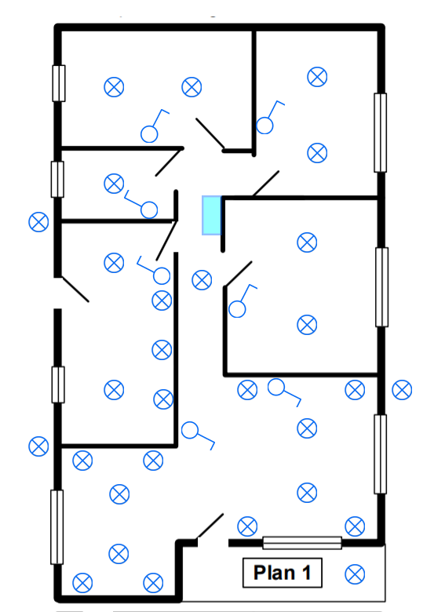**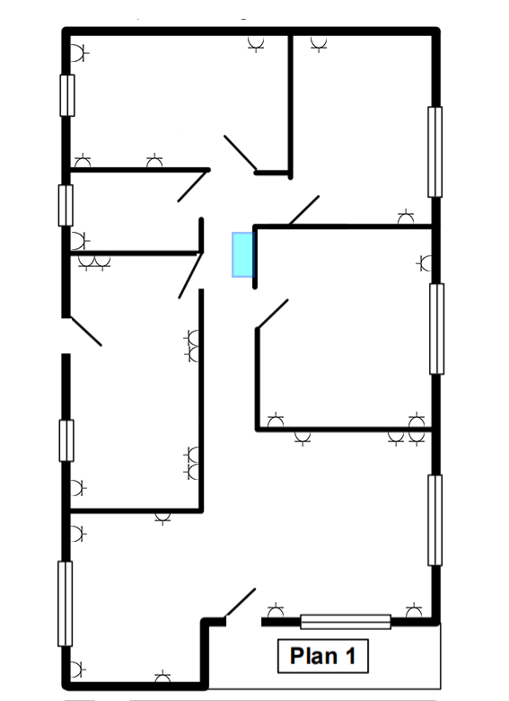­­­­­**

**6,7,8 . Lamp, Socket outlet and Fan layouts**

L6

L5

L4

L3

S23

S22

S24

S21

S20

S19

L7

S25

L10

L8

L2

S14

S13

S10

L29

L11

L1

S16

S15

L12

S12

S11

L28

L27

L26

L25

L13

L9

S26

S18

S17

S5

S6

S7

L24

L16

L15

L14

S2

S1

L22

L21

L18

L17

S8

S9

L23

L20

L19

S4

S3

Lamp Layout with Switches

Socket Outlet Layout

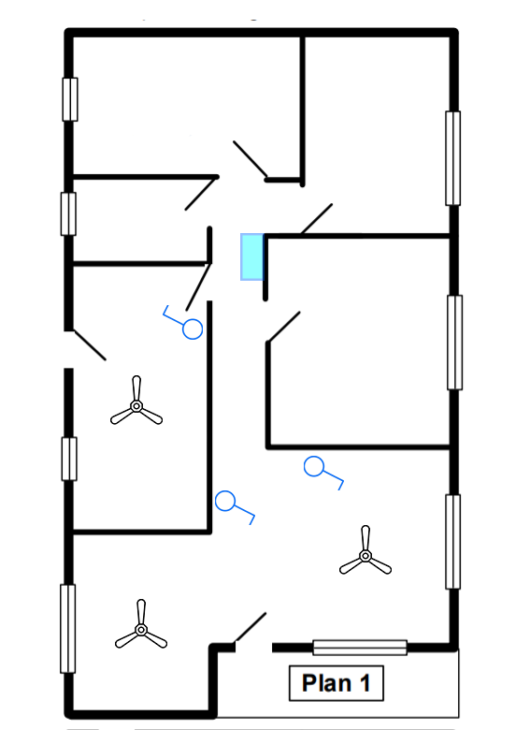

Dedicated circuit

Ring circuit

Radial circuit



Plug socket



LED lamp



Switches

F1

Ceiling Fan



Distribution Box

F3

F2

Fan Layout

S18

S17

S16

S15

S14

S13

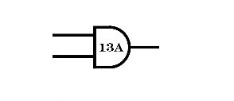

**9. Diagrams**

**RCCB   
40 A**

6A

1/1.13

**3-way MCB**

S2

S3

S4

S1

3

6A



7/0.67



4

7/0.67



S9

S8

S7

S6

S5

16A

L7

L3

1

L5

L4

L2

L1

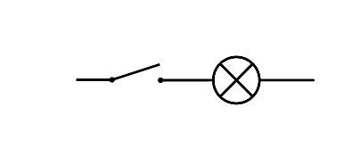

L6



5

32A

7/0.67

6

16A

7/0.67

S12

S11

S10



F3

F2

F1

12

1/1.13

6A



L8

L9

L10

2

**RCCB   
40 A**

6A



1/1.13

**6-way MCB**

L14

L13

L12



L11

L15

L16



L21

L20

L19



L18

L17



L22

L23



L27

L26

L25

L24



L29

L28



S22

S23

7



7/0.67



16A



7/0.67

S21

S200

S19

8

16A

9

7/0.67

S24

16A



S25

1/1.13



10

6A

11

16A



7/0.67

S26

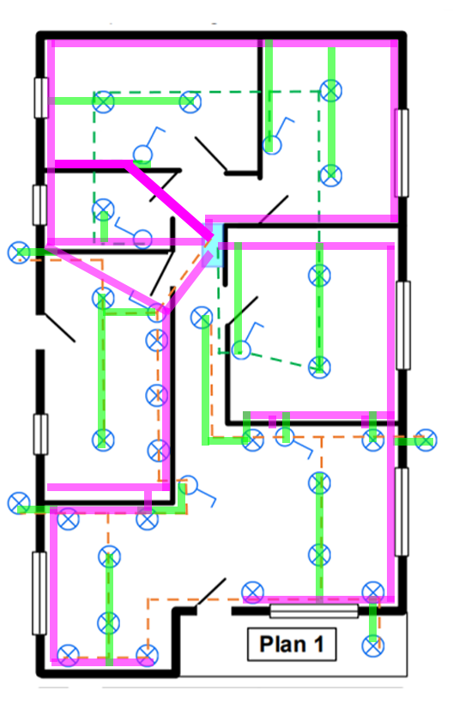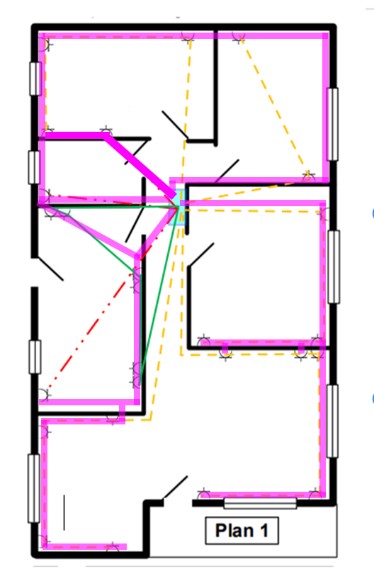

**10 . Conduit layouts**

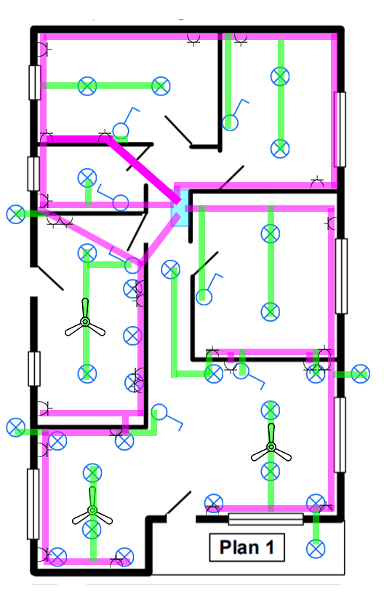

Conduit layout for lights

Conduit layout for sockets outlet

1” Conduit

¾” Conduit

Final conduit layout

Lightening in bedroom 1, bedroom 2, bedroom 3 and toilet

40A, 30mA RCCB

Plug sockets in dining room

Plug sockets in living room

Plug sockets in kitchen

Plug sockets in bedroom 1

Fans in the dining room, kitchen and living room

Lightening in living and dining room, kitchen and outdoor

L and N- 1 mm2, E - 1 mm2

L and N- 2.5 mm2, E – 2.5 mm2

L and N- 2.5 mm2, E – 2.5 mm2

L and N- 2.5 mm2, E – 2.5 mm2

L and N- 1 mm2, E – 1 mm2

L and N- 2.5 mm2, E – 2.5 mm2

L and N- 1 mm2, E - 1 mm2

L and N- 2.5 mm2, E -2.5 mm2

L and N- 2.5 mm2, E - 2.5 mm2

L and N- 2.5 mm2, E – 2.5 mm2

L and N- 1 mm2, E – 1 mm2

L and N- 2.5 mm2, E – 2.5 mm2

Plug sockets in bedroom 2

Plug sockets in bedroom 3

A dedicated line for the 1.5 kW Air conditioner in bedroom 1

A dedicated line for the 1 kW instantaneous water heater in the toilet

A dedicated line for the 2.5 kW oven unit in the kitchen

40A, 1P

40A, 30mA RCCB

**Approximate Costs (in rupees)**

*Note that the costs are given in LKR

|  |  |  |  |
| --- | --- | --- | --- |
| 1 mm2 wire (100 m) | Rs. 5000 – single core | Ceiling roses | Rs. 275 |
| 1.5 mm2 wire (100 m) | Rs. 20000 – two core | 13A socket | Rs. 900 |
| 2.5 mm2 wire (100 m) | Rs. 30000 – two core | Switches | Rs. 300 per gang |
| Earth wires (100 m) | Rs. 15000 | MCB | Rs. 800 |
| Fan | Rs.13000 | Conduits 1” | Rs. 750 per m |
| Main switch | Rs. 2500 | Conduits 3/4” | Rs. 500 per m |
| Trip switch | Rs. 5000 | Holder | Rs. 225 |
| Bends, Plastic boxes, junction boxes | Rs. 100 | LED lamp | Rs.2000 – 5W wall lamp  Rs.800 – 18W  Rs.2500 – 20W  Rs.3000 – 24W |

Workmanship fees – Rs.750 per point

**11. Bill Of Quantities (BOQ)**

1. For ring plug circuit

|  |  |
| --- | --- |
|  | For circuit 5 (15m) |
| For plug sockets | 5400 |
| Cost for L and N wires | 9000 |
| Cost for Earth wires | 2250 |
| Cost for conduit (Took 60% of wire length) | 6750 |
| Cost for bends, plastic boxes, junction boxes | 300 |
| Workmanship fees | 750x6 = 4500 |
| Total | 28200 |

Total cost for ring plug circuits = 28200

1. For radial plug circuits

|  |  |  |
| --- | --- | --- |
|  | For circuit 10 (5m) | For circuit 4 (12m) |
| For plug sockets | 900 | 4500 |
| Cost for L and N wires | 500 | 7200 |
| Cost for Earth wires | 750 | 1800 |
| Cost for conduit (Took 60% of wire length) | 2250 | 5400 |
| Cost for bends, plastic boxes, junction boxes | 100 | 200 |
| Workmanship fees | 750 | 3750 |
| Total | 5250 | 22850 |

Average cost = 14050

Total cost for radial plug circuits = 14050 x 8 = 112400

1. For lightening circuits

|  |  |  |
| --- | --- | --- |
|  | For circuit 1 (20m) | For circuit 2 (30m) |
| For lamps | 15800 | 44700 |
| Cost for L and N wires | 2000 | 3000 |
| Holders | 1575 | 4950 |
| Switches and sunk boxes | 1600 | 1200 |
| Ceiling roses | 1925 | 3025 |
| Cost for conduit (Took 60% of wire length) | 6000 | 9000 |
| Cost for bends, plastic boxes, junction boxes | 700 | 1400 |
| Workmanship fees | 750x7 = 5250 | 750x22 = 16500 |
| Total | 34850 | 83775 |

Total cost for lightening circuits = 118625

1. For Fan circuit

|  |  |
| --- | --- |
|  | For circuit 12 (22m) |
| For Fans | 13000 x 3 = 39000 |
| Cost for L and N wires | 2200 |
| Cost for Earth wires | 1000 |
| Switches and sunk boxes | 1200 |
| Cost for conduit (Took 60% of wire length) | 6600 |
| Cost for bends, plastic boxes, junction boxes | 400 |
| Workmanship fees | 750x3 = 2250 |
| Total | 52650 |

Total cost for fan circuits = 52650

**Total cost**

|  |  |
| --- | --- |
| Description | Cost (rupees) |
| Main switch | 2500 |
| Trip switch | 5000 |
| MCB’s | 9600 |
| Radial plug socket circuits | 112400 |
| Ring plug socket circuit | 28200 |
| Lightening circuits | 118625 |
| Fan circuit | 52650 |
| Total Cost | 328975 |

**Total cost = 328,975 LKR**